Developing a Backend Admin for Learner’s Academy

****Project objective:-****

As a Full Stack Developer, design and develop a backend administrative portal for the Learner’s Academy. Use the GitHub repository to manage the project artifacts.

****Background of the problem statement:-****

Learner’s Academy is a school that has an online management system. The system keeps track of its classes, subjects, students, and teachers. It has a back-office application with a single administrator login.

**GitHub :- <https://github.com/Aniket03-op/Project.git>**

**Source Code:-**

# Class.java

**package** core.model;

**public class** Class {

**private int** id; **private** String section; **private** String teacher; **private** String subject; **private** String time;

**public** Class(**int** id, String section, String teacher, String subject, String time)

{

**super**(); **this**.id = id;

**this**.section = section; **this**.teacher = teacher; **this**.subject = subject; **this**.time = time;

}

**public int** getId() {

**return** id;

}

**public void** setId(**int** id) {

**this**.id = id;

}

**public** String getSection() {

**return** section;

}

**public void** setSection(String section) {

**this**.section = section;

}

**public** String getTeacher() {

**return** teacher;

}

**public void** setTeacher(String teacher) {

**this**.teacher = teacher;

}

**public** String getSubject() {

**return** subject;

}

**public void** setSubject(String subject) {

**this**.subject = subject;

}

**public** String getTime() {

**return** time;

}

**public void** setTime(String time) {

**this**.time = time;

}

}

# Student.java

**package** core.model;

**public class** Student { **private int** id; **private** String fname; **private** String lname; **private int** age; **private int** aclass;

**public** Student(**int** id, String fname, String lname, **int** age, **int** aclass) {

**super**(); **this**.id = id;

**this**.fname = fname; **this**.lname = lname; **this**.age = age; **this**.aclass = aclass;

}

**public int** getId() {

**return** id;

}

**public void** setId(**int** id) {

**this**.id = id;

}

**public** String getFname() {

**return** fname;

}

**public void** setFname(String fname) {

**this**.fname = fname;

}

**public** String getLname() {

**return** lname;

}

**public void** setLname(String lname) {

**this**.lname = lname;

}

**public int** getAge() {

**return** age;

}

**public void** setAge(**int** age) {

**this**.age = age;

}

**public int** getAclass() {

**return** aclass;

}

**public void** setAclass(**int** aclass) {

**this**.aclass = aclass;

}

@Override

**public** String toString() {

**return** "Student [id=" + id + ", fname=" + fname + ", lname=" + lname + ", age=" + age + ", aclass=" + aclass

+ "]";

}

}

# Subject.java

**package** core.model;

**public class** Subject {

**private int** id;

**private** String name;

**private** String shortcut;

**public** Subject(**int** id, String name, String shortcut ) {

**super**(); **this**.id = id;

**this**.name = name;

**this**.shortcut = shortcut;

}

**public int** getId() {

**return** id;

}

**public void** setId(**int** id) {

**this**.id = id;

}

**public** String getShortcut() {

**return** shortcut;

}

**public void** setShortcut(String shortcut) {

**this**.shortcut = shortcut;

}

**public** String getName() {

**return** name;

}

**public void** setName(String name) {

**this**.name = name;

}

}

# Teacher.java

**package** core.model;

**public class** Teacher {

**private int** id; **private** String fname; **private** String lname; **private int** age;

**public** Teacher(**int** id, String fname, String lname, **int** age) {

**super**(); **this**.id = id;

**this**.fname = fname; **this**.lname = lname; **this**.age = age;

}

**public int** getId() {

**return** id;

}

**public void** setId(**int** id) {

**this**.id = id;

}

**public** String getFname() {

**return** fname;

}

**public void** setFname(String fname) {

**this**.fname = fname;

}

**public** String getLname() {

**return** lname;

}

**public void** setLname(String lname) {

**this**.lname = lname;

}

**public int** getAge() {

**return** age;

}

**public void** setAge(**int** age) {

**this**.age = age;

}

}

## AdminControllerServlet.java (servlet)

package core.project;

import java.io.IOException; import java.util.List;

import javax.annotation.Resource; import javax.servlet.RequestDispatcher; import javax.servlet.ServletException;

import javax.servlet.annotation.WebServlet; import javax.servlet.http.Cookie;

import javax.servlet.http.HttpServlet;

import javax.servlet.http.HttpServletRequest; import javax.servlet.http.HttpServletResponse; import javax.sql.DataSource;

import core.model.Student; import core.model.Subject; import core.model.Teacher; import core.model.Class;

/**

* Servlet implementation class AdminControllerServlet

*/ @WebServlet("/AdminControllerServlet")

public class AdminControllerServlet extends HttpServlet { private static final long serialVersionUID = 1L;

private DbRetrive dbRetrieve;

@Resource(name = "/db_world") private DataSource datasource;

@Override

public void init() throws ServletException {

super.init();

// create instance of db util, to pass in conn pool object try {

dbRetrieve = new DbRetrive(datasource);

} catch (Exception e) {

throw new ServletException(e);

}

}

/**

* @see HttpServlet#HttpServlet()

*/

public AdminControllerServlet() { super();

// TODO Auto-generated constructor stub

}

@Override

protected void doPost(HttpServletRequest req, HttpServletResponse resp) throws ServletException, IOException {

doGet(req, resp);

}

/**

* @see HttpServlet#doGet(HttpServletRequest request, HttpServletResponse
* response)

*/

protected void doGet(HttpServletRequest request, HttpServletResponse response)

throws ServletException, IOException {

// TODO Auto-generated method stub try {

// read the "command" parameter

String command = request.getParameter("command");

if (command == null) {

command = "CLASSES";

}

// if no cookeies

if (!getCookies(request, response) && (!command.equals("LOGIN"))) {

response.sendRedirect("/Administrative-Portal/login.jsp");

}

else {

// if there is no command, how to handle

// route the data to the appropriate method switch (command) {

case "STUDENTS":

studentsList(request, response); break;

case "TEACHERS":

teachersList(request, response); break;

case "SUBJECTS":

subjectList(request, response); break;

case "CLASSES":

classestList(request, response); break;

case "ST_LIST":

classStudentsList(request, response); break;

case "LOGIN":

login(request, response); break;

default:

classestList(request, response);

}

}

} catch (Exception e) {

throw new ServletException(e);

}

// response.getWriter().append("Served at: ").append(request.getContextPath());

}

private void studentsList(HttpServletRequest request, HttpServletResponse response) throws Exception {

// get students from db util

List<Student> students = dbRetrieve.getStudents();

// add students to the request request.setAttribute("STUDENT_LIST", students);

// send it to the jsp view page RequestDispatcher dispatcher =

request.getRequestDispatcher("/list-students.jsp"); dispatcher.forward(request, response);

}

private void teachersList(HttpServletRequest request, HttpServletResponse response) throws Exception {

// get students from db util

List<Teacher> teachers = dbRetrieve.getTeachers();

// add students to the request request.setAttribute("TEACHERS_LIST", teachers);

// send it to the jSP view page RequestDispatcher dispatcher =

request.getRequestDispatcher("/teachers-list.jsp"); dispatcher.forward(request, response);

}

private void subjectList(HttpServletRequest request, HttpServletResponse response) throws Exception {

// get subjects from db util

List<Subject> subjects = dbRetrieve.getSubjects();

// add subjects to the request request.setAttribute("SUBJECTS_LIST", subjects);

// send it to the jSP view page

RequestDispatcher dispatcher = request.getRequestDispatcher("/subjects-list.jsp");

dispatcher.forward(request, response);

}

private void classestList(HttpServletRequest request, HttpServletResponse response) throws Exception {

// get subjects from db util

List<Class> classes = dbRetrieve.getClasses();

// add subjects to the request request.setAttribute("CLASSES_LIST", classes);

// send it to the jSP view page RequestDispatcher dispatcher =

request.getRequestDispatcher("/classes-list.jsp"); dispatcher.forward(request, response);

}

private void login(HttpServletRequest request, HttpServletResponse response) throws Exception {

String username = request.getParameter("username"); String password = request.getParameter("password");

if (username.toLowerCase().equals("admin") && password.toLowerCase().equals("admin")) {

Cookie cookie = new Cookie(username, password);

// Setting the maximum age to 1 day cookie.setMaxAge(86400); // 86400 seconds in a day

// Send the cookie to the client response.addCookie(cookie); classestList(request, response);

} else {

RequestDispatcher dispatcher = request.getRequestDispatcher("/login.jsp");

dispatcher.forward(request, response);

}

}

private void classStudentsList(HttpServletRequest request, HttpServletResponse response) throws Exception {

int classId = Integer.parseInt(request.getParameter("classId")); String section = request.getParameter("section");

String subject = request.getParameter("subject");

// get subjects from db util

List<Student> students = dbRetrieve.loadClassStudents(classId);

// add subjects to the request request.setAttribute("STUDENTS_LIST", students); request.setAttribute("SECTION", section); request.setAttribute("SUBJECT", subject);

// send it to the jSP view page RequestDispatcher dispatcher =

request.getRequestDispatcher("/class-students.jsp"); dispatcher.forward(request, response);

}

private boolean getCookies(HttpServletRequest request, HttpServletResponse response) throws Exception {

boolean check = false;

Cookie[] cookies = request.getCookies();

// Find the cookie of interest in arrays of cookies for (Cookie cookie : cookies) {

if (cookie.getName().equals("admin") && cookie.getValue().equals("admin")) {

check = true; break;

}

} return check;

}

}

# DbRetrive.java

package core.project;

import java.sql.Connection; import java.sql.DriverManager; import java.sql.ResultSet; import java.sql.Statement; import java.util.ArrayList; import java.util.List;

import javax.sql.DataSource;

import core.model.Student;

import core.model.Subject; import core.model.Teacher; import core.model.Class;

public class DbRetrive {

private DataSource dataSource;

public DbRetrive(DataSource dataSource) { this.dataSource = dataSource;

}

public List<Student> getStudents() {

List<Student> students = new ArrayList<>();

Connection myConn = null; Statement myStmt = null; ResultSet myRs = null;

try {

// get a connection

myConn = dataSource.getConnection();

// create sql stmt

String sql = "SELECT * FROM students"; myStmt = myConn.createStatement();

// execute query

myRs = myStmt.executeQuery(sql);

// process result while (myRs.next()) {

// retrieve data from result set row int id = myRs.getInt("id");

String fname = myRs.getString("fname"); String lname = myRs.getString("lname"); int age = myRs.getInt("age");

int aclass = myRs.getInt("class");

// create new student object

Student tempStudent = new Student(id, fname, lname, age,

aclass);

// add it to the list of students students.add(tempStudent);

}

} catch (Exception e) {

// TODO: handle exception

} finally {

// close JDBC objects close(myConn, myStmt, myRs);

}

return students;

}

public List<Teacher> getTeachers() {

List<Teacher> teachers = new ArrayList<>();

Connection myConn = null; Statement myStmt = null; ResultSet myRs = null;

try {

// get a connection

myConn = dataSource.getConnection();

// create sql stmt

String sql = "SELECT * FROM teachers"; myStmt = myConn.createStatement();

// execute query

myRs = myStmt.executeQuery(sql);

// process result while (myRs.next()) {

// retrieve data from result set row int id = myRs.getInt("id");

String fname = myRs.getString("fname"); String lname = myRs.getString("lname"); int age = myRs.getInt("age");

// create new student object

Teacher temp = new Teacher(id, fname, lname, age);

// add it to the list of students teachers.add(temp);

}

} catch (Exception e) {

// TODO: handle exception

} finally {

// close JDBC objects close(myConn, myStmt, myRs);

}

return teachers;

}

public List<Subject> getSubjects() {

List<Subject> subjects = new ArrayList<>();

Connection myConn = null; Statement myStmt = null; ResultSet myRs = null;

try {

// get a connection

myConn = dataSource.getConnection();

// create sql stmt

String sql = "SELECT * FROM subjects"; myStmt = myConn.createStatement();

// execute query

myRs = myStmt.executeQuery(sql);

// process result while (myRs.next()) {

// retrieve data from result set row int id = myRs.getInt("id");

String name = myRs.getString("name"); String shortcut = myRs.getString("shortcut");

// create new student object

Subject temp = new Subject(id, name,shortcut);

// add it to the list of students subjects.add(temp);

}

} catch (Exception e) {

// TODO: handle exception

} finally {

// close JDBC objects close(myConn, myStmt, myRs);

}

return subjects;

}

public List<Class> getClasses() {

List<Class> classes = new ArrayList<>();

Connection myConn = null; Statement myStmt = null; ResultSet myRs = null;

try {

// get a connection

myConn = dataSource.getConnection();

// create sql stmt

String sql = "SELECT * FROM classes"; myStmt = myConn.createStatement();

// execute query

myRs = myStmt.executeQuery(sql);

// process result while (myRs.next()) {

// retrieve data from result set row int id = myRs.getInt("id");

String section = myRs.getString("section"); int subject = myRs.getInt("subject");

int teacher = myRs.getInt("teacher"); String time = myRs.getString("time");

Teacher tempTeacher = loadTeacher(teacher); Subject tempSubject = loadSubject(subject);

String teacher_name = tempTeacher.getFname() + " " +

tempTeacher.getLname();

// create new student object

Class temp = new Class(id, section, teacher_name, tempSubject.getName(), time);

// add it to the list of students classes.add(temp);

}

} catch (Exception e) {

// TODO: handle exception

} finally {

// close JDBC objects close(myConn, myStmt, myRs);

}

return classes;

}

public Teacher loadTeacher(int teacherId) {

Teacher theTeacher = null;

Connection myConn = null; Statement myStmt = null; ResultSet myRs = null;

try {

// get a connection

myConn = dataSource.getConnection();

// create sql stmt

String sql = "SELECT * FROM teachers WHERE id = " + teacherId; myStmt = myConn.createStatement();

// execute query

myRs = myStmt.executeQuery(sql);

// process result while (myRs.next()) {

// retrieve data from result set row int id = myRs.getInt("id");

String fname = myRs.getString("fname"); String lname = myRs.getString("lname"); int age = myRs.getInt("age");

theTeacher = new Teacher(id, fname, lname, age);

}

} catch (Exception e) {

// TODO: handle exception

} finally {

// close JDBC objects close(myConn, myStmt, myRs);

}

return theTeacher;

}

public Subject loadSubject(int subjectId) {

Subject theSubject = null;

Connection myConn = null; Statement myStmt = null; ResultSet myRs = null;

try {

// get a connection

myConn = dataSource.getConnection();

// create sql stmt

String sql = "SELECT * FROM subjects WHERE id = " + subjectId; myStmt = myConn.createStatement();

// execute query

myRs = myStmt.executeQuery(sql);

// process result while (myRs.next()) {

// retrieve data from result set row int id = myRs.getInt("id");

String name = myRs.getString("name"); String shortcut = myRs.getString("shortcut");

theSubject = new Subject(id, name,shortcut);

}

} catch (Exception e) {

// TODO: handle exception

} finally {

// close JDBC objects close(myConn, myStmt, myRs);

}

return theSubject;

}

public Class loadClass(int classId) {

Class theClass = null;

Connection myConn = null; Statement myStmt = null; ResultSet myRs = null;

try {

// get a connection

myConn = dataSource.getConnection();

// create sql stmt

String sql = "SELECT * FROM clasess WHERE id = " + classId; myStmt = myConn.createStatement();

// execute query

myRs = myStmt.executeQuery(sql);

// process result while (myRs.next()) {

// retrieve data from result set row int id = myRs.getInt("id");

String section = myRs.getString("section"); int subject = myRs.getInt("subject");

int teacher = myRs.getInt("teacher"); String time = myRs.getString("time");

Teacher tempTeacher = loadTeacher(teacher); Subject tempSubject = loadSubject(subject);

String teacher_name = tempTeacher.getFname() + " " +

tempTeacher.getLname();

}

} catch (Exception e) {

// TODO: handle exception

} finally {

// close JDBC objects close(myConn, myStmt, myRs);

}

return theClass;

}

public List<Student> loadClassStudents(int classId) {

List<Student> students = new ArrayList<>();

Connection myConn = null; Statement myStmt = null; ResultSet myRs = null;

try {

// get a connection

myConn = dataSource.getConnection();

// create sql stmt

String sql = "SELECT * FROM students WHERE class = " + classId; myStmt = myConn.createStatement();

// execute query

myRs = myStmt.executeQuery(sql);

// process result while (myRs.next()) {

// retrieve data from result set row int id = myRs.getInt("id");

String firstName = myRs.getString("fname"); String lastName = myRs.getString("lname"); int age = myRs.getInt("age");

int aclass = myRs.getInt("class");

// create new student object

Student tempStudent = new Student(id, firstName, lastName, age,

aclass);

students.add(tempStudent);

}

} catch (Exception e) {

// TODO: handle exception

} finally {

// close JDBC objects close(myConn, myStmt, myRs);

}

return students;

}

private void close(Connection myConn, Statement myStmt, ResultSet myRs) {

try {

if (myRs != null) {

myRs.close();

}

if (myStmt != null) {

myStmt.close();

}

if (myConn != null) {

myConn.close();

}

} catch (Exception e) {

e.printStackTrace();

}

}

}

## TestServlet.java

package core.project;

import java.io.IOException; import java.io.PrintWriter; import java.sql.Connection;

import java.sql.ResultSet; import java.sql.Statement;

import javax.annotation.Resource; import javax.servlet.ServletException;

import javax.servlet.annotation.WebServlet; import javax.servlet.http.HttpServlet;

import javax.servlet.http.HttpServletRequest; import javax.servlet.http.HttpServletResponse; import javax.sql.DataSource;

/**

* Servlet implementation class TestServlet

*/ @WebServlet("/TestServlet")

public class TestServlet extends HttpServlet {

private static final long serialVersionUID = 1L;

//Define datasource/connection pool for reference

@Resource(name="db_world") private DataSource dataSource;

/**

* @see HttpServlet#doGet(HttpServletRequest request, HttpServletResponse response)

*/

protected void doGet(HttpServletRequest request, HttpServletResponse response) throws ServletException, IOException {

// Set the printwriter

PrintWriter out = response.getWriter(); response.setContentType("text/plain");

// establish connection to the DB Connection myConn = null; Statement myStmt = null; ResultSet myRs = null;

try {

myConn = dataSource.getConnection();

//create a sql statement

String sql = "select * from students"; myStmt = myConn.createStatement();

//execute the sql statement

myRs = myStmt.executeQuery(sql);

//process the resultset while(myRs.next()) {

String fname = myRs.getString("fname"); out.println(fname);

}

}

catch(Exception e) {

e.printStackTrace();

}

}

}

## CSS

* + **add-student-style.css**

**form** {

margin-top: *10px*;

}

**label** {

font-size: *16px*; width: *100px*; display: *block*; text-align: *right*; margin-right: *10px*; margin-top: *8px*; margin-bottom: *8px*;

}

**input** {

width: *250px*;

border: *1px solid #666*; border-radius: *5px*; padding: *4px*;

font-size: *16px*;

}

*.save* {

font-weight: *bold*; width: *130px*; padding: *5px 10px*; margin-top: *30px*; background: *#cccccc*;

}

**table** {

border-style:*none*; width:*50%*;

}

**tr***:nth-child(even)* {background: *#FFFFFF*}

**tr***:nth-child(odd)* {background: *#FFFFFF*}

**tr** {

border-style:*none*; text-align:*left*;

}

## login.css

**Body** {

font-family: *Calibri, Helvetica, sans-serif*; background-color: *white*;

}

**button** {

justify-content: *center*; background-color: *#ff8040*; width: *100%*;

color: *white*; padding: *15px*;

margin: *10px 0px*; border: *none*; cursor: *pointer*;

}

**form** {

border: *1.4px solid black*; width: *45%*;

margin: *0 auto*;

}

**input**[type=text]**, input**[type=password] { justify-content: *center*;

width: *100%*;

margin: *8px 0*; padding: *12px 20px*; display: *inline-block*;

border: *2px solid #c0c0c0*; box-sizing: *border-box*;

}

**button***:hover* {

opacity: *0.7*;

}

*.container* {

justify-content: *center*; padding: *15px*;

background-color: *#FFF8DC*;

}

## style.css

**html, body**{

padding:*0px*;

font-family:*Verdana, Arial, Helvetica, sans-serif*;

margin-left: *103px*; /* Same as the width of the sidenav */

}

**table** {

border-collapse:*collapse*; border:*1px solid gray*;

font-family: *Tahoma,Verdana,Segoe,sans-serif*; width:*80%*;

}

**th** {

border-bottom:*1px solid gray*; background:*none repeat scroll 0 0 #008040*; padding:*10px*;

color: *#FFFFFF*;

}

**tr** {

border-top:*1px solid gray*;

text-align:*center*;

}

**tr***:nth-child(even)* {background: *#FFFFFF*}

**tr***:nth-child(odd)* {background: *#BBBBBB*}

*#wrapper* {width: *100%*; text-align: *center*; }

*#header* {width: *80%*; background: *#ff8040*; margin-top: *0px*; padding:*5px 0px 15px 0px*;} *#header* **h3** {width: *100%*; margin:*auto*; color: *#FFFFFF*;}

*#container* {width: *100%*; margin:*auto*} *#container* **h3** {color: *#008040*;} *#container #content* {margin-top: *20px*;}

*.add-student-button* {

border: *1px solid #666*; border-radius: *5px*; padding: *4px*;

font-size: *12px*; font-weight: *bold*; width: *120px*; padding: *5px 10px*;

margin-bottom: *15px*; background: *#cccccc*;

}

*.sidenav* { height: *100%*; width: *200px*;

border-color: *#FFFFFF*; position: *fixed*;

z-index: *1*;

top: *0*;

left: *0*;

background-color: *#008040*; overflow-x: *hidden*; padding-top: *20px*;

}

*.sidenav* **a** {

padding: *6px 6px 6px 32px*; text-decoration: *none*; font-size: *25px*;

color: *white*; display: *block*;

}

*.sidenav* **a***:hover* { color: *#ff8040*;

}

@media screen and (max-height: 450px) {

*.sidenav* {padding-top: *15px*;}

*.sidenav* **a** {font-size: *18px*;}

}

*#page*{

height: *100%*;

}

*#logo*{

font-family: *'Trebuchet MS', sans-serif*; text-align: *center*;

color: *#ffff80*;

}

*.bar-item*{

border-color: *#FFFFFF*; border-width: *3px*;

border-bottom: *.5px solid rgba(255, 255, 255, 0.247)*;

}

* **Context.xml**

<Context>

<Resource name=*"db_world"*

auth=*"Container"* type=*"javax.sql.DataSource"* maxActive=*"20"* maxIdle=*"5"* maxWait=*"10000"* username=*"root"* password=*"root"* driverClassName=*"com.mysql.jdbc.Driver"*

url=*"jdbc:mysql://localhost:3306/db_world"*/>

</Context>

## web.xml

<?xml version=*"1.0"* encoding=*"UTF-8"*?>

<element>

<web-app xmlns:xsi=*"<http://www.w3.org/2001/XMLSchema-instance>"* xmlns=*"<http://java.sun.com/xml/ns/javaee>"* xsi:schemaLocation=*"<http://java.sun.com/xml/ns/javaee> <http://java.sun.com/xml/ns/javaee/web-app_3_0.xsd>"* id=*"WebApp_ID"* version=*"3.0"*>

<display-name>ServletAndJSP</display-name>

<welcome-file-list>

<welcome-file>index.html</welcome-file>

<welcome-file>index.htm</welcome-file>

<welcome-file>index.jsp</welcome-file>

<welcome-file>default.html</welcome-file>

<welcome-file>default.htm</welcome-file>

<welcome-file>default.jsp</welcome-file>

<welcome-file>login.html</welcome-file>

</welcome-file-list>

<display-name>Administrative-Portal-For Learner -Academy</display-name>

<welcome-file-list>

<welcome-file>AdminControllerServlet</welcome-file>

<welcome-file>index.jsp</welcome-file>

<welcome-file>index.html</welcome-file>

</welcome-file-list>

<servlet>

<display-name>AdminControllerServlet</display-name>

<servlet-name>AdminControllerServlet</servlet-name>

<servlet-class>core.project.AdminControllerServlet</servlet-class>

</servlet>

<servlet-mapping>

<servlet-name>AdminControllerServlet</servlet-name>

<url-pattern>/AdminControllerServlet</url-pattern>

</servlet-mapping>

<servlet>

<display-name>TestServlet</display-name>

<servlet-name>TestServlet</servlet-name>

<servlet-class>core.project.TestServlet</servlet-class>

</servlet>

<servlet-mapping>

<servlet-name>TestServlet</servlet-name>

<url-pattern>/TestServlet</url-pattern>

</servlet-mapping>

<servlet>

<description></description>

<display-name>at</display-name>

<servlet-name>at</servlet-name>

<servlet-class>core.project.RetriveProduct</servlet-class>

</servlet>

<servlet-mapping>

<servlet-name>at</servlet-name>

<url-pattern>/retrive</url-pattern>

</servlet-mapping>

</web-app>

</element>

## login.jsp

<%@ taglib uri=*"<http://java.sun.com/jsp/jstl/core>"* prefix=*"c"*%>

<!DOCTYPE html>

<html>

<head>

<meta charset=*"ISO-8859-1"*>

<title>Login</title>

<link type=*"text/css"* rel=*"stylesheet"* href=*"css/login.css"*>

</head>

<body style="background-image: *url('css/background.jpg')*;">

<center> <h1> Admin Login </h1> </center>

<form action=*"AdminControllerServlet"* method=*"POST"*>

<div class=*"container"*>

<input type=*"hidden"* name=*"command"* value=*"LOGIN"* />

<label>Username : </label>

<br/>

<input type=*"text"* placeholder=*"Enter Username"* name=*"username"* required>

<br/>

<label>Password : </label>

<br/>

<input type=*"password"* placeholder=*"Enter Password"* name=*"password"*

required>

<br/>

<button type=*"submit"*>Login</button>

<br/>

<input type=*"checkbox"* checked=*"checked"*> Remember me

</div>

</form>

</body>

</html>

## class-student.jsp

<%@ taglib uri=*"<http://java.sun.com/jsp/jstl/core>"* prefix=*"c"*%>

<!DOCTYPE html>

<html>

<head>

<meta charset=*"ISO-8859-1"*>

<title>Students of a Class</title>

<link type=*"text/css"* rel=*"stylesheet"* href=*"css/style.css"*>

</head>

<body style="background-image: *url('css/background.jpg')*;">

<div id=*"page"* >

<jsp:include page=*"left-list.jsp"* />

<div id=*"wrapper"*>

<div id=*"header"*>

<h3>Students of ${SUBJECT} class section ${SECTION} </h3>

</div>

</div>

<div id=*"container"*>

<div id=*"content"*>

<table>

<tr>

<th>First Name</th>

<th>Last Name</th>

<th>age</th>

</tr>

<c:forEach var=*"tempStudent"*

items=*"*${STUDENTS_LIST}*"*>

<tr>

<td>${tempStudent.fname}</td>

<td>${tempStudent.lname}</td>

<td>${tempStudent.age}</td>

</tr>

</c:forEach>

</table>

</div>

</div>

</div>

</body>

</html>

## Classes-list.jsp

<%@ taglib uri=*"<http://java.sun.com/jsp/jstl/core>"* prefix=*"c"*%>

<!DOCTYPE html>

<html>

<head>

<meta charset=*"ISO-8859-1"*>

<title>List of Classes</title>

<link type=*"text/css"* rel=*"stylesheet"* href=*"css/style.css"*>

</head>

<body style="background-image: *url('css/background.jpg')*;">

<div id=*"page"*>

<jsp:include page=*"left-list.jsp"* />

<div id=*"wrapper"*>

<div id=*"header"*>

<h3>Classes</h3>

</div>

</div>

<div id=*"container"*>

<div id=*"content"*>

<table>

<tr>

<th>Section</th>

<th>Subject</th>

<th>Teacher</th>

<th>Time</th>

<th>List of Students</th>

</tr>

<c:forEach var=*"tempClass"* items=*"*${CLASSES_LIST }*"*>

<tr>

<c:url var=*"tempLink"*

value=*"AdminControllerServlet"*>

<c:param name=*"command"*

value=*"ST_LIST"* />

<c:param name=*"classId"*

value=*"*${tempClass.class_id }*"* />

<c:param name=*"section"*

value=*"*${tempClass.section }*"* />

<c:param name=*"subject"*

value=*"*${tempClass.subject }*"* />

</c:url>

<td>${tempClass.section}</td>

<td>${tempClass.subject}</td>

<td>${tempClass.teacher}</td>

<td>${tempClass.time}</td>

<td><a href=*"*${tempLink }*"*>List</a></td>

</tr>

</c:forEach>

</table>

</div>

</div>

</div>

</body>

</html>

## left-list.jsp

<%@ taglib uri=*"<http://java.sun.com/jsp/jstl/core>"* prefix=*"c"*%>

<div class=*"sidenav"*>

<h3 id=*"logo"*>

Administrative <br /> Academy Portal

</h3>

<c:url var=*"classesLink"* value=*"AdminControllerServlet"*>

<c:param name=*"command"* value=*"CLASSES"* />

</c:url>

<c:url var=*"subjectsLink"* value=*"AdminControllerServlet"*>

<c:param name=*"command"* value=*"SUBJECTS"* />

</c:url>

<c:url var=*"teachersLink"* value=*"AdminControllerServlet"*>

<c:param name=*"command"* value=*"TEACHERS"* />

</c:url>

<c:url var=*"studentsLink"* value=*"AdminControllerServlet"*>

<c:param name=*"command"* value=*"STUDENTS"* />

</c:url>

<a class=*"bar-item"* href=*"*${classesLink}*"*>Classes</a>

<a class=*"bar-item"* href=*"*${subjectsLink}*"*>Subjects</a>

<a class=*"bar-item"* href=*"*${teachersLink}*"*>Teachers</a>

<a class=*"bar-item"* href=*"*${studentsLink}*"*>Students</a>

<a class=*"bar-item"* href=*"login.jsp"*>Log out</a>

</div>

## list-students.jsp

<%@ taglib uri=*"<http://java.sun.com/jsp/jstl/core>"* prefix=*"c"*%>

<!DOCTYPE html>

<html>

<head>

<meta charset=*"ISO-8859-1"*>

<title>List of Students</title>

<link type=*"text/css"* rel=*"stylesheet"* href=*"css/style.css"*>

</head>

<body style="background-image: *url('css/background.jpg')*;">

<div id=*"page"* >

<jsp:include page=*"left-list.jsp"* />

<div id=*"wrapper"*>

<div id=*"header"*>

<h3>Students</h3>

</div>

</div>

<div id=*"container"*>

<div id=*"content"*>

<table>

<tr>

<th>First Name</th>

<th>Last Name</th>

<th>age</th>

</tr>

<c:forEach var=*"tempStudent"* items=*"*${STUDENT_LIST

}*"*>

<tr>

<td>${tempStudent.fname}</td>

<td>${tempStudent.lname}</td>

<td>${tempStudent.age}</td>

</tr>

</c:forEach>

</table>

</div>

</div>

</div>

</body>

</html>

## subjects-list.jsp

<%@ taglib uri=*"<http://java.sun.com/jsp/jstl/core>"* prefix=*"c"*%>

<!DOCTYPE html>

<html>

<head>

<meta charset=*"ISO-8859-1"*>

<title>List of Teachers</title>

<link type=*"text/css"* rel=*"stylesheet"* href=*"css/style.css"*>

</head>

<body style="background-image: *url('css/background.jpg')*;">

<div id=*"page"*>

<jsp:include page=*"left-list.jsp"* />

<div id=*"wrapper"*>

<div id=*"header"*>

<h3>Subjects</h3>

</div>

</div>

<div id=*"container"*>

<div id=*"content"*>

<table>

<tr>

<th>Name</th>

<th>Shortcut</th>

</tr>

<c:forEach var=*"tempSubject"* items=*"*${SUBJECTS_LIST

}*"*>

<tr>

<td>${tempSubject.name}</td>

<td>${tempSubject.shortcut}</td>

</tr>

</c:forEach>

</table>

</div>

</div>

</div>

</body>

</html>

## teachers-list.jsp

<%@ taglib uri=*"<http://java.sun.com/jsp/jstl/core>"* prefix=*"c"*%>

<!DOCTYPE html>

<html>

<head>

<meta charset=*"ISO-8859-1"*>

<title>List of Teachers</title>

<link type=*"text/css"* rel=*"stylesheet"* href=*"css/style.css"*>

</head>

<body style="background-image: *url('css/background.jpg')*;">

<div id=*"page"*>

<jsp:include page=*"left-list.jsp"* />

<div id=*"wrapper"*>

<div id=*"header"*>

<h3>Teachers</h3>

</div>

</div>

<div id=*"container"*>

<div id=*"content"*>

<table>

<tr>

<th>First Name</th>

<th>Last Name</th>

<th>age</th>

</tr>

<c:forEach var=*"tempStudent"* items=*"*${TEACHERS_LIST

}*"*>

<tr>

<td>${tempStudent.fname}</td>

<td>${tempStudent.lname}</td>

<td>${tempStudent.age}</td>

</tr>

</c:forEach>

</table>

</div>

</div>

</div>

</body>

</html>

**Output:**

1. Admin Login Page:

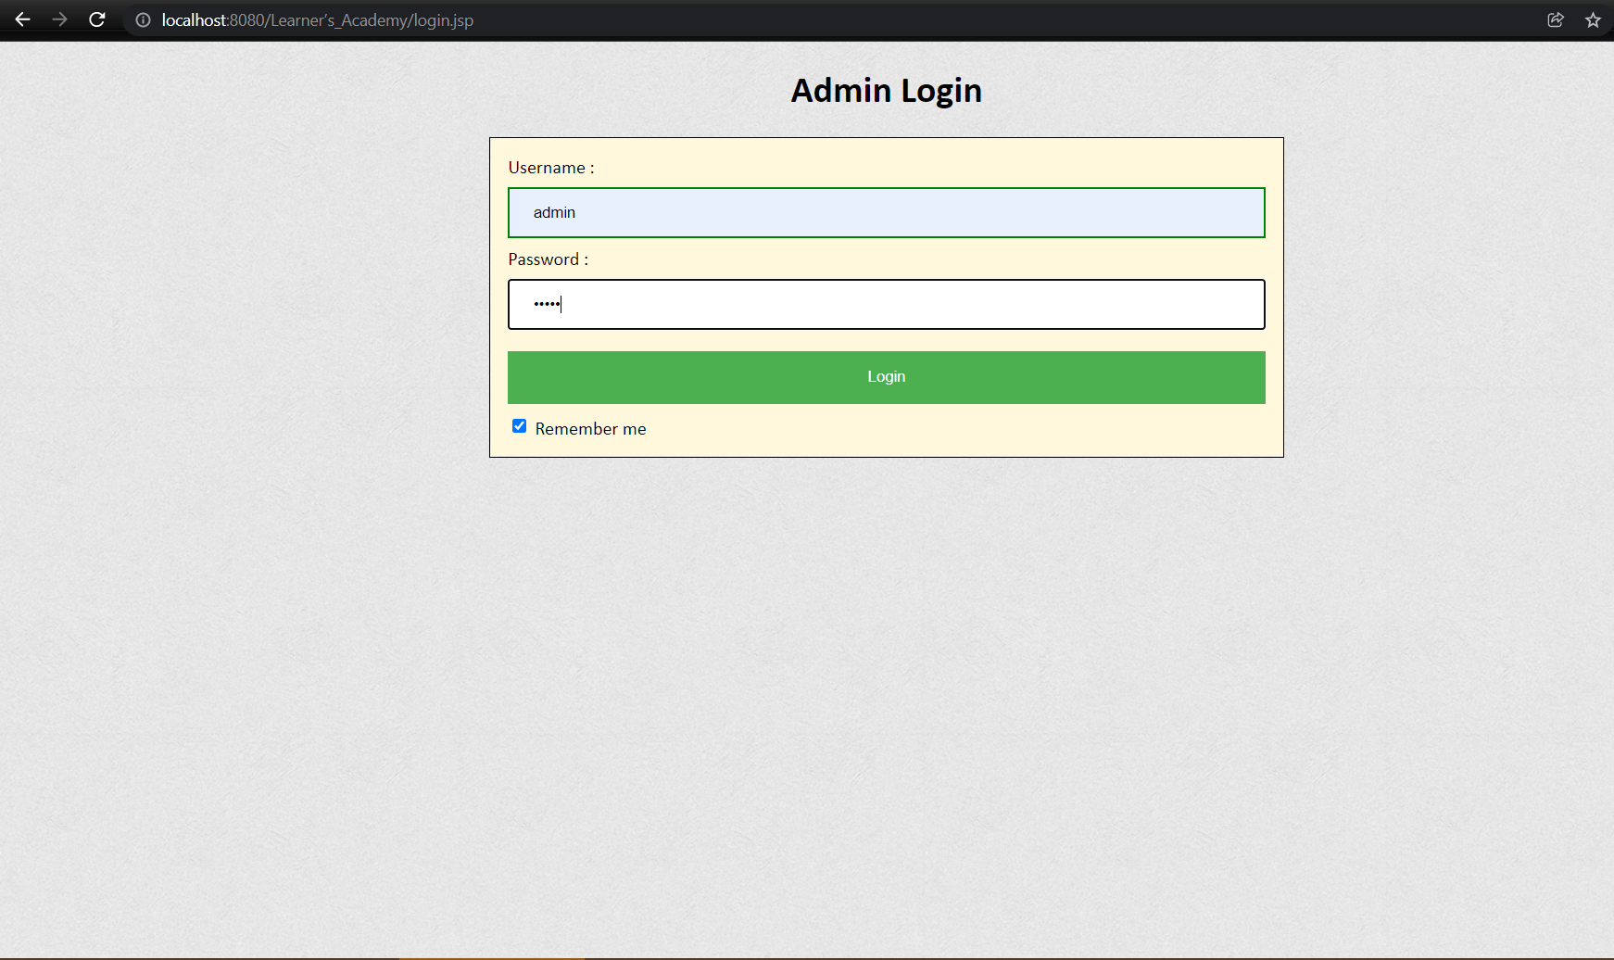

2. Classes:

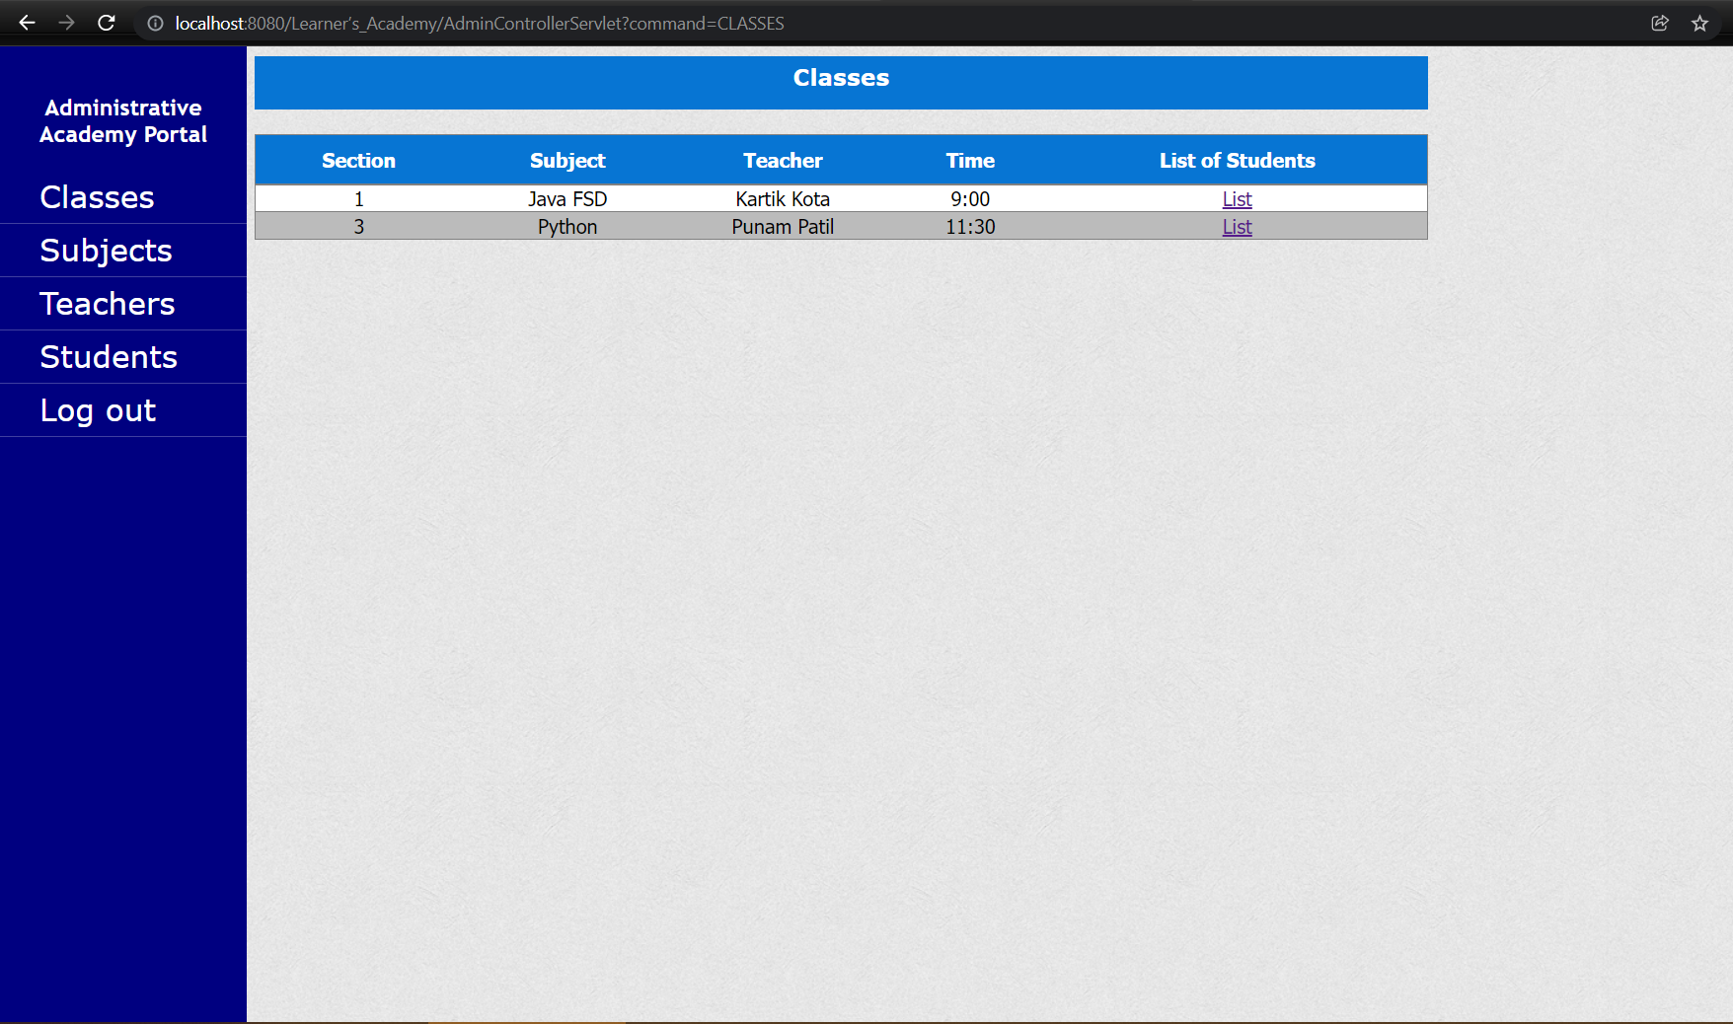

3. Subjects List:

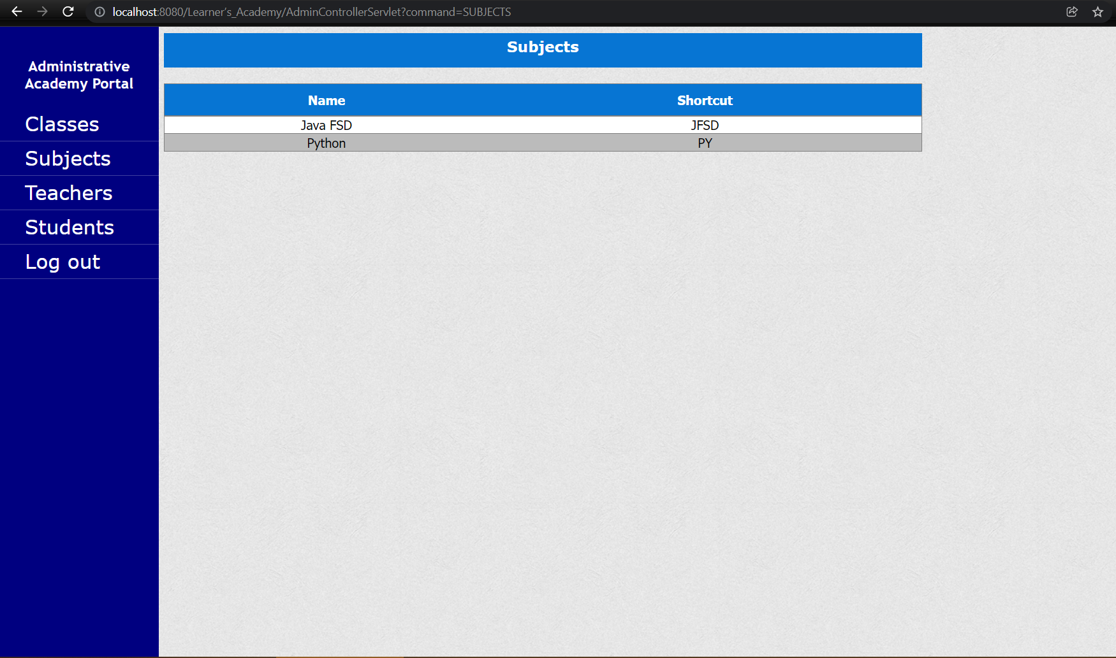

4. Teacher’s List:

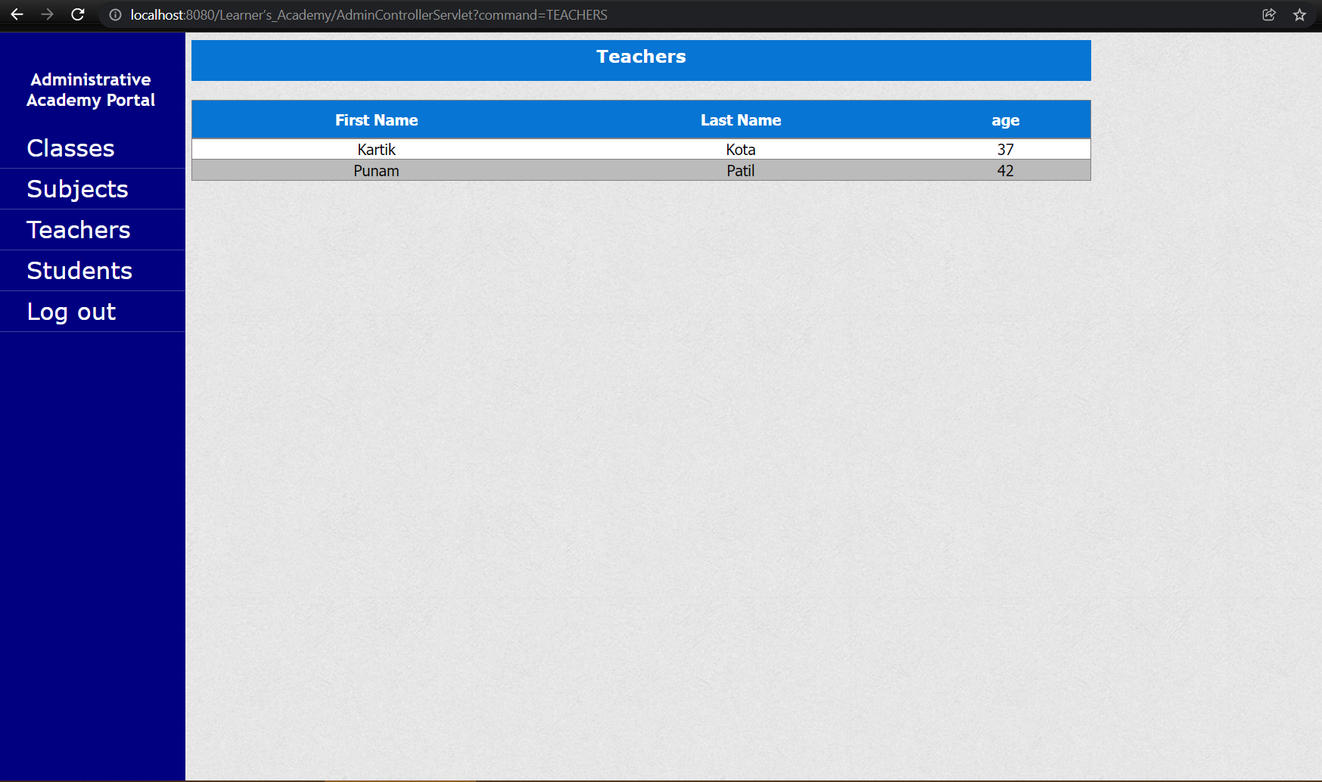

5. Student’s List:

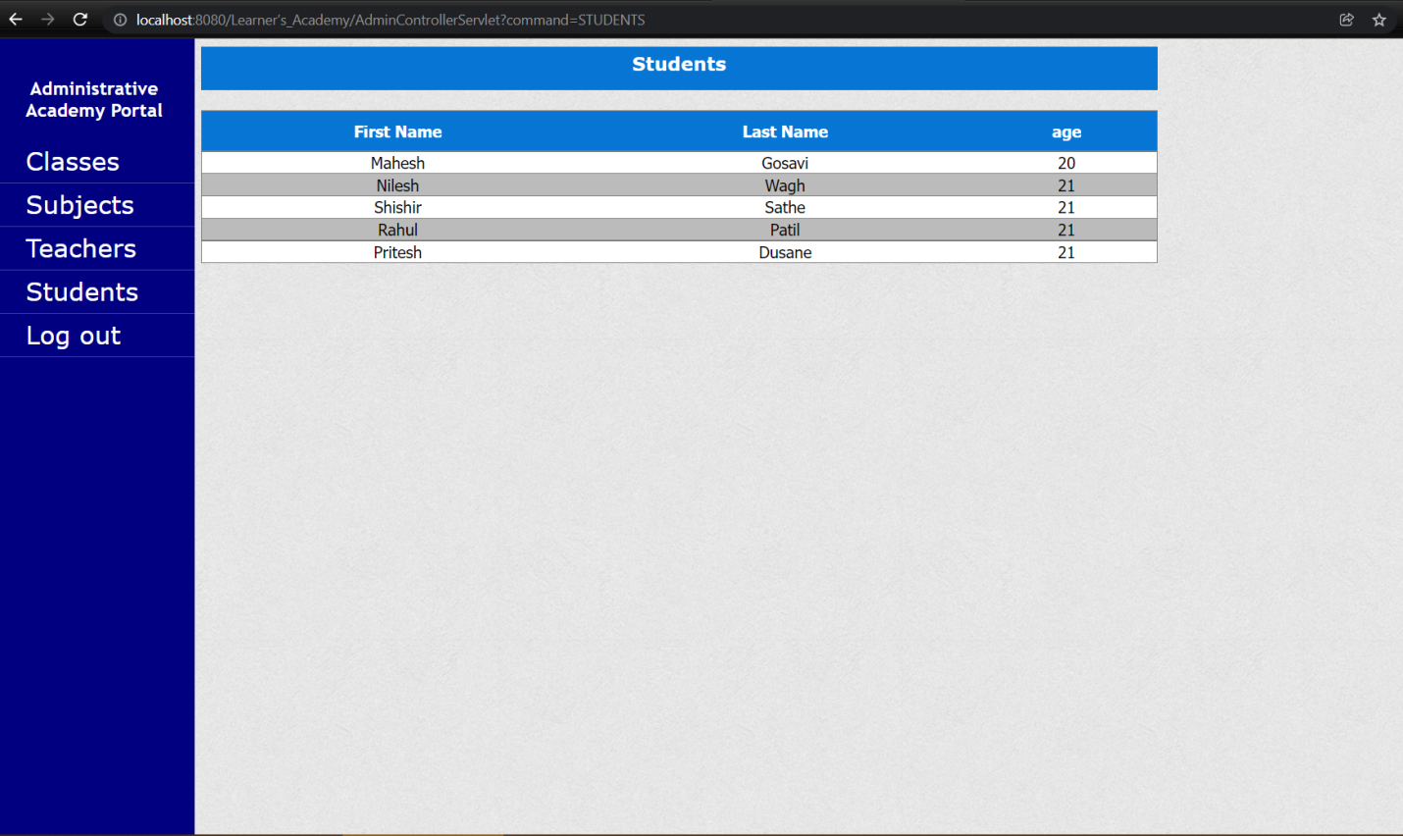

6. Subject Wise Student’s List:

